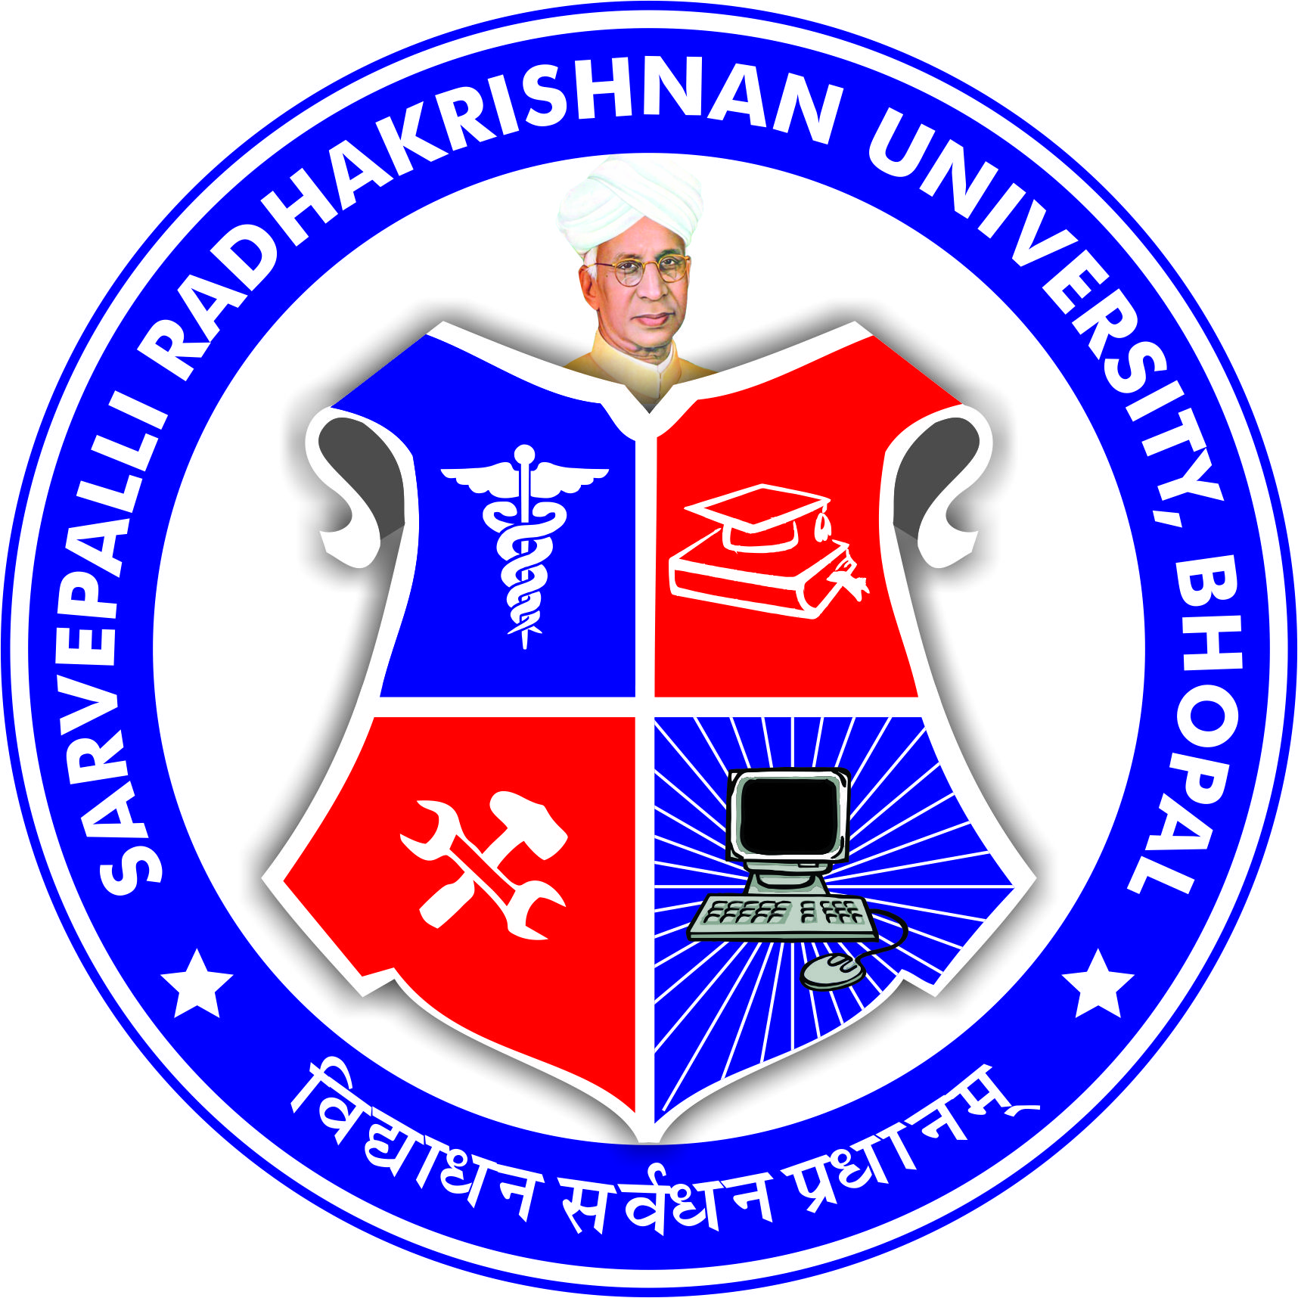
SARVEPALLI RADHAKRISHNAN UNIVERSITY
NH 12,RKDF IST CAMPUS, HOSHANGABAD ROAD, MISROD, BHOPAL (M.P.)
¼Statutory University established by Govt. of M.P. under section 2(F½ of UGC act)
www.srku.edu.in, info@srku.edu.in,Phone: 0755-4700981 Fax: 07554700981

Equal Opportunity Cell
As per UGC guidelines Equal Opportunity Cell of Sarvepalli Radhakrishnan University is constituted as under-

S. No. | Name | Designation | Position
1. | Dr. Priyanka Jaiswal | Vice Chancellor | Chairperson
2. | Dr. Sushil Singh | Chairman Student Grievance Committee | Member
3. | Dr. Richa Gupta | Chairman Staff Grievance Committee | Member
4. | Dr. Namrata Jain | Director IQAC | Member
5. | Dr. Archna Selwan | Chairman Internal Committee | Member
6. | Shri Rohan Gupta | Student Representative | Member
7. | Dr. Bharti Chourasiya | Antidiscriminatory Officer | Member

